**Experiment 3**

|  |  |
| --- | --- |
| **Student Name**: SANSKAR AGRAWAL | **UID:** 20BCS5914 |
| **Branch**: CSE | **Section/Group:** 806/B |
| **Semester**: 5th | **Date of Performance**: 17/08/2022 |
| **Subject Name**: DAA Lab | **Subject Code:** 20CSP-312 |

**1. Aim/Overview of the practical:**

Calculating frequency of array elements.

**2. Task to be done/ Which logistics used:**

Vs Code IDE, C++ Language, C++ Compiler, Concepts of Recursion etc**.**

**3. Algorithm/Flowchart:**

1. Begin

2. Declare and initialize an array arr.

3. Declare another array freq with the same size of array arr, to store the frequencies

of elements present in the array.

4. Variable visited will be initialized with the value -1.

5. Initialize count to 1 in the first loop to maintain a count of each element.

6. Increment its value by 1 if a duplicate element is found in the second loop.

7. Mark this element as visited by setting freq[j] = 0.

8. Store count of each element to freq.

9. Finally, print out the element along with its frequency.

10. End

**4. Code:**

//frequency of each element of an array

#include<iostream>

using namespace std;

int main()

{

int i,n,j,ct;

cin>>n;

int arr[n],freq[n];

for(i=0;i<n;i++)

{

cin>>arr[i];

freq[i]=-1;

}

for(i=0;i<n;i++)

{

ct=1;

for(j=i+1;j<n;j++)

{

if(arr[i]==arr[j])

{

ct++;

freq[j]=0;

}

}

if(freq[i]!=0)

freq[i]=ct;

}

cout<<endl<<"Element\t|\tFrequency"<<endl;

for(i=0;i<n;i++)

{

if(freq[i]!=0)

cout<<arr[i]<<"\t|\t"<<freq[i]<<endl;

}

cout<<"\n\n\t----SANSKAR AGRAWAL 20BCS5914";

}

**5. Observations/Discussions/ Complexity Analysis:**

In the above program, a nested for loop is used to calculate the frequency of each element in the array. Each of those for loops run for n times. Hence, n x n = n2 is the time complexity. The time complexity of the algorithm is O(n 2 ), where n is the number of elements.

**6. Output:**

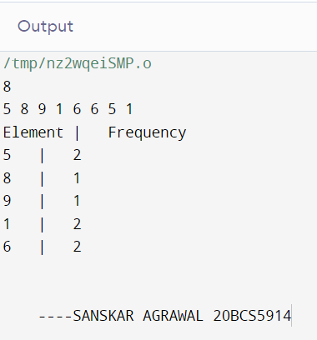

**Learning outcomes (What I have learnt):**

1. We learnt about time complexity.
2. We learnt to calculate time complexity of programs and thereby create the most optimal program possible.
3. We learned to create a program for calculating frequency of elements in an array with time complexity O(n2 )

**Evaluation Grid (To be created as per the SOP and Assessment guidelines by the faculty):**

|  |  |  |  |
| --- | --- | --- | --- |
| Sr. No. | Parameters | Marks Obtained | Maximum Marks |
| 1. |  |  |  |
| 2. |  |  |  |
| 3. |  |  |  |
|  |  |  |  |